Abdull Haseeb
SU92-BSAIM-F24-050
BSAI-3A
LAB NO 11

Documentation for “AI Lab Task 11”
1. Dataset Loading
The program begins by importing the required library and loading a dataset named bank.csv. After loading, the first few rows are displayed to verify that the dataset has been imported correctly. 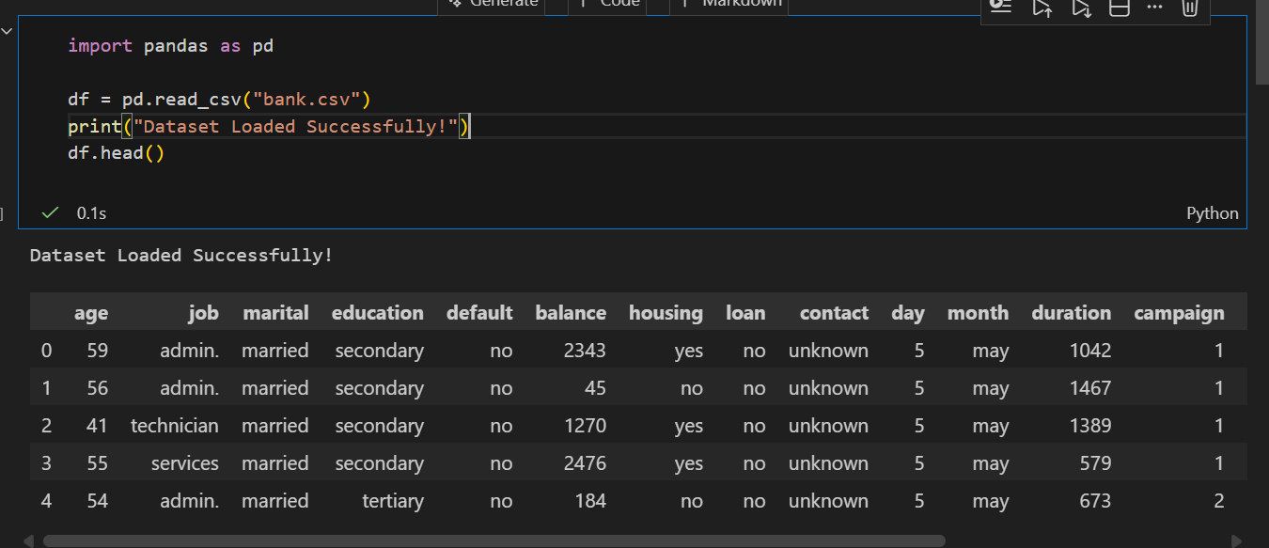

2. Checking for Missing Values
Before starting preprocessing, the program prints the total number of missing (null) values in each column. This helps identify which columns require cleaning.
The code then fills or removes the missing values using an appropriate method (such as filling with mean, median, or a specific value).
After cleaning, the program prints the updated null-value count to confirm that all missing values have been resolved. 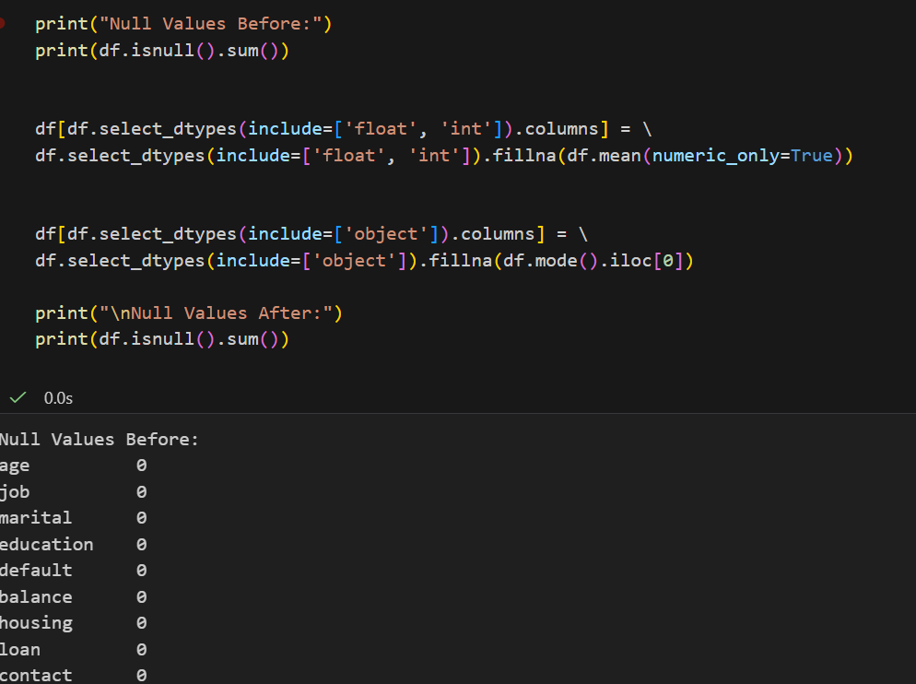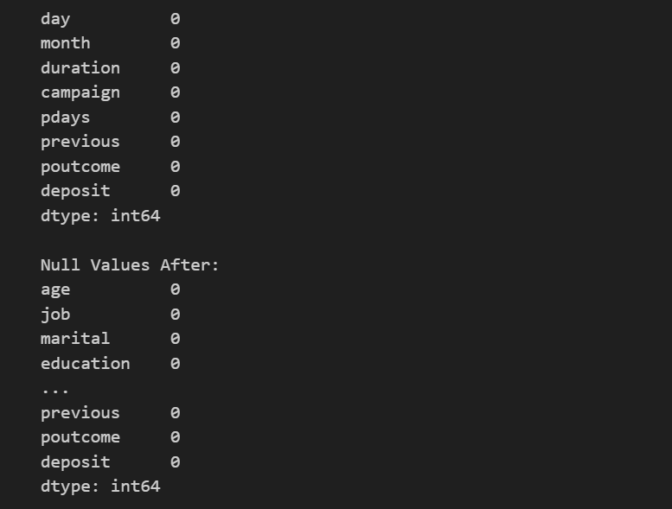

3. Data Type Conversion
The program checks each column’s data type.
If a column contains values that should be integers but are currently stored as floats or strings, the program converts them to the correct numeric type.
This ensures that the dataset is consistent and ready for machine learning operations. 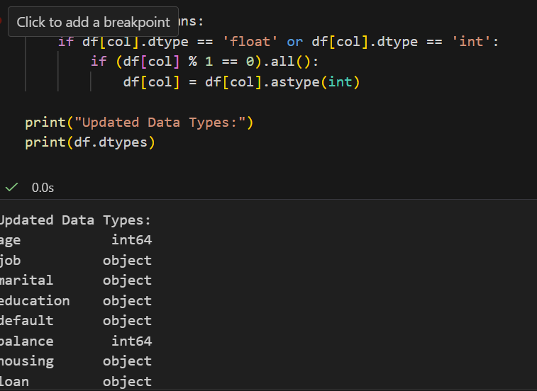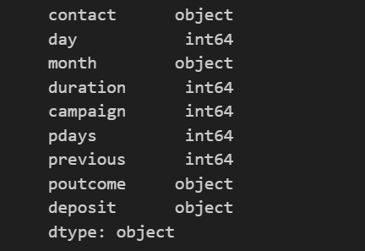

4. Encoding Categorical Variables
Many machine learning algorithms only work with numerical data.
The program uses Label Encoding to convert text-based categorical columns (such as job, education, marital status, etc.) into numerical values.
Each unique category is assigned an integer so the model can interpret it.
A message is displayed to confirm that encoding is complete. 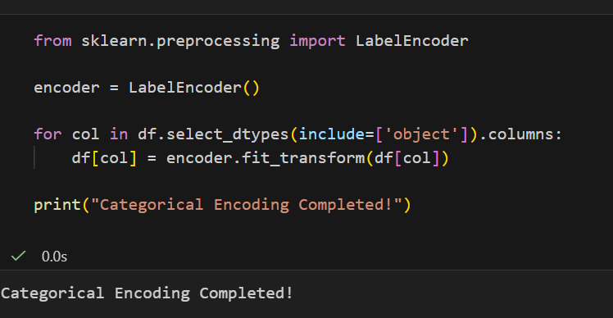

5. Train–Test Split
The dataset is divided into:
- Features (X): All input columns
- Target (y): The output column you want to predict
The program then splits the data into:
- Training set (used to train the model)
- Testing set (used to evaluate the model)
An 80/20 split is used, and a random seed is applied to ensure reproducibility.
A confirmation message is printed after the split. 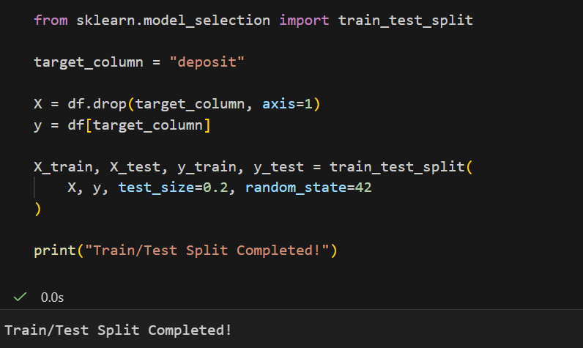

6. Model Training (if present later in notebook)
If your notebook continues beyond the extracted cells, the next steps typically include:
- Selecting a machine learning model
- Training the model using the training data
- Evaluating performance using accuracy, confusion matrix, or other metrics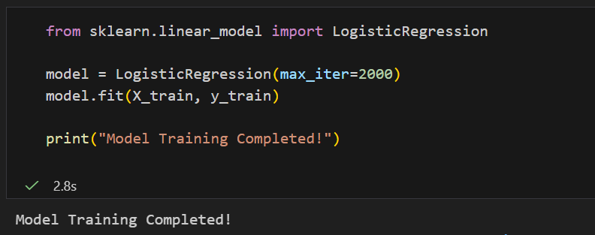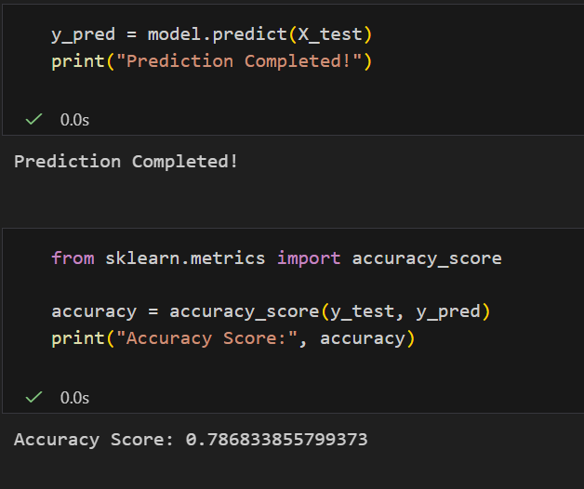

7. Summary
Overall, the notebook performs the following tasks:
- Loads the dataset
- Checks and handles missing values
- Converts incorrect data types
- Encodes categorical data
- Splits the dataset for training and testing
This ensures the data is clean, consistent, and ready for machine learning modeling.

